COS20007 -Object Oriented Programming

Semester Test (Week 8)

Lecturer:   Mr. Nguyen Duc Dung

Hai Hoang Le | s103542974

**Question 1:**

1. **Optimized New UML Diagram**

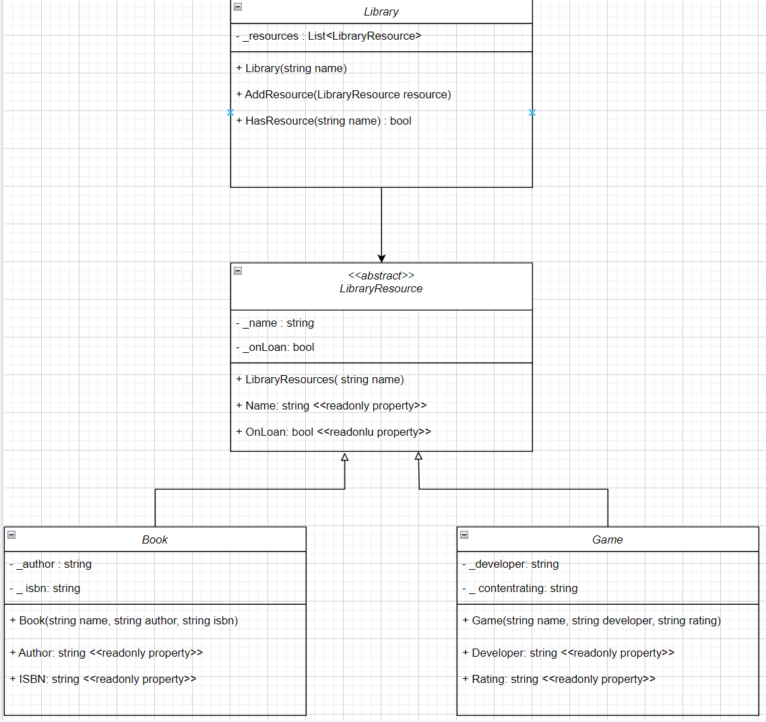

1. **See at the attached zip file**
2. **Result screenshot:**

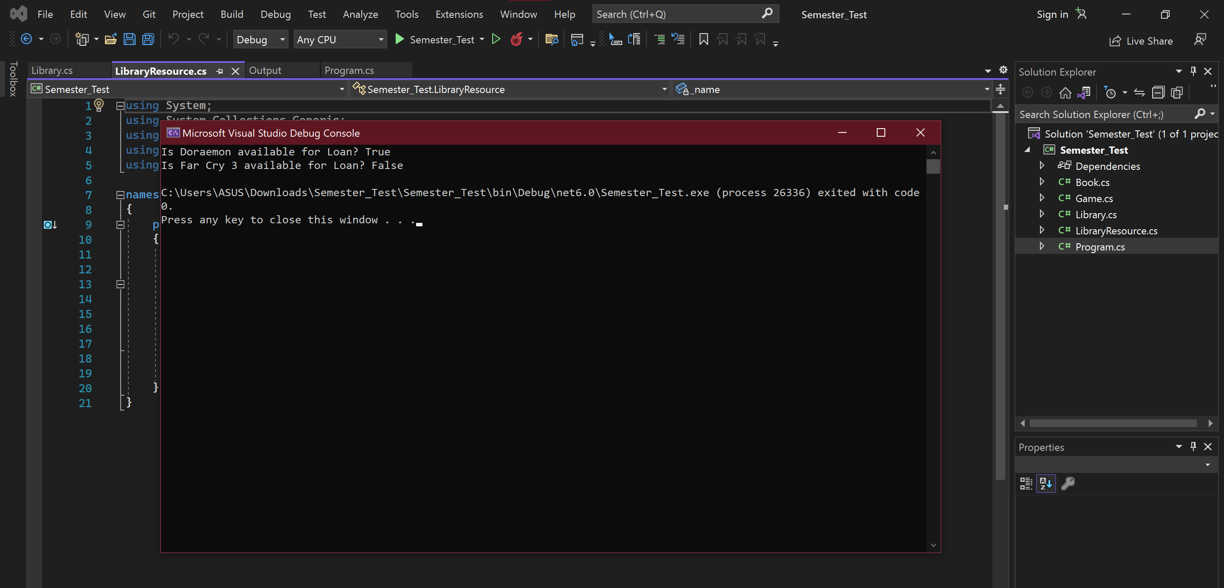

**Question 2:**

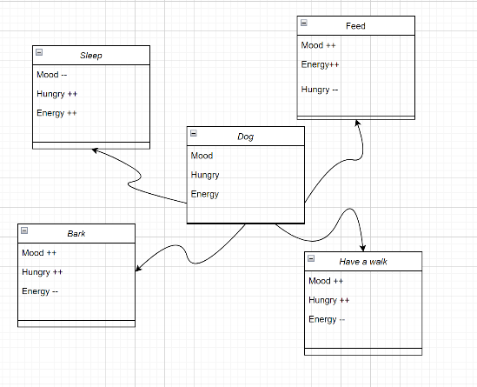Among the course of COS20007, We learned about the C# language that is an object –oriented programing. There are four main basic principles of object oriented programing: encapsulation, abstraction, inheritance and polymorphism. As a beginner in coding, it will be difficult for people to understand the meaning as well as the functionality of these four principles. Firstly, we need to understand the concept of object oriented programing. For example, let consider a dog is a class, it is clearly that a dog will have some properties such as hungry, energy, mood. These properties value of state won’t be changed by outside object, within the dog can bark whenever it wants, so we will call it as private value. However, we can interact with the dog when it sleeping, eating or barking, these activities are call public method and these would affect the state of the dog. This design in object programing is call encapsulation (create relationship between private value and public method).

Example Diagram

Abstraction is a kind of extension of encapsulation. In a big project, when the program has hundreds of relationship between object, the process of maintenance or developing will be difficult. Abstract will solve the problem when each object only expose a high – level mechanism for using it. For example, the are many processes happen when you press the power button on laptop.

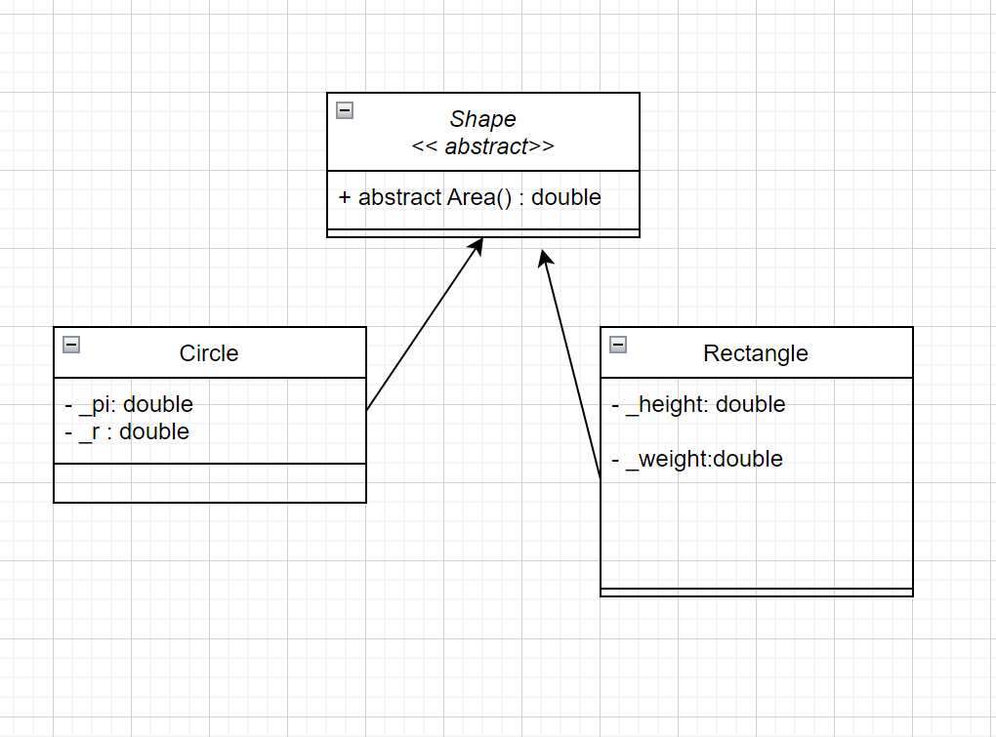Polymorphism means “many shapes” in Greek, each child class has the same way when is called but it still has its own method. For example as the diagram below:

The Circle and Rectangle classes use the same method Area(). So the Shape class allow to create a new list of circle or rectangle, those list will be watched as unique object. In addition, we can calculate the area of the new object, when we want to caluculate.